A Person Centred Planning Approach to Annual Reviews
– A Guide for Educational Settings
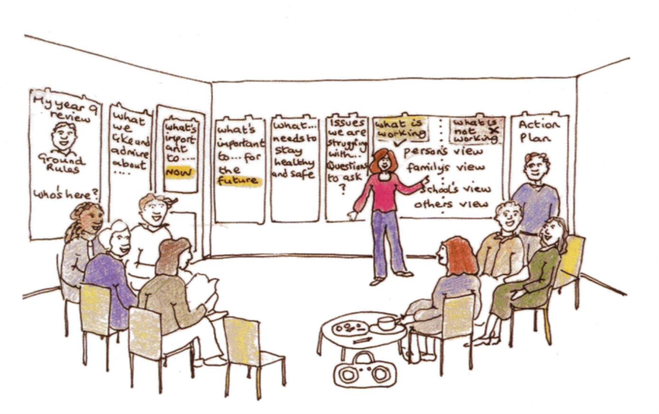

Table of Contents
A Person Centred Planning Approach to Annual Reviews – A Guide for Educational Settings 1
Section 1. Introduction 3
Section 2: What is Person Centred Planning (PCP)? 3
Section 3: A Person Centred Planning (PCP) approach to an Annual Review 4
A. Who should be invited to the Annual Review? 5
B. Invitation Letter (see Appendix F) 5
C. Prior to the Annual Review 6
D. The Facilitator 7
E. At the Annual Review Meeting 8
F. The Action Plan 10
G. Closing the Meeting 10
Section 4: Appendices 12
A. Flipchart Sheet Headings 12
B. Annual Review Agenda Template 14
C. Ground Rules 15
D. The Person Centred Planning Approach to Annual Review Meetings – Checklist 16
E. One Page Profile 18
F. Examples of Person Centred Planning Annual Review Invitations 19
G. SMART targets 20

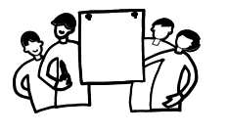

Section 1. Introduction
The Children and Families Act 2014 set out clear principles for supporting and involving children / young people in all aspects of the support and planning of their special educational needs. Local
Authorities must have regard to the views, wishes and feelings of the children / young people and their parents / carers.

The Special Educational Needs and Disability Code of Practice: 0 – 25 years provides the statutory guidance relating to part 3 of the Children and Families Act 2014. Embedded in its principles is the need for a stronger focus on the participation of children / young people and their parents / carers in decision making at both individual and strategic levels. The use of person centred approaches provide the opportunity to fulfil these principles. Working in this way ensures children / young people and their parents / carers are at the centre of all decision making and future planning.

A person centred annual review provides an opportunity to engage directly with children / young people to discuss their needs, and plan how they can achieve the best possible outcomes. This should be integral to all planning for children / young people with Special Educational Need and Disability (SEND) throughout their lives.

A person centred approach to an annual review is a practical way of ensuring that the principles that underpin the SEND Code of Practice are upheld.

This guidance document, for educational establishments, provides information about how to adopt a person centred approach to annual reviews.

Section 2: What is Person Centred Planning (PCP)?

Both research and experience has shown that Person Centred Planning makes a significant impact to the child / young person and their families.

PCP aims to put children and young people at the centre of planning and decisions that affect them. Paragraph 8.1 of the Code of Practice (2015) states:
‘Local authorities must place children, young people and families at the centre of their planning….’
When children / young people are meaningfully involved, it can change their attitude, behaviour and learning and make them active participants who work with adults to bring about change.



The benefits of a PCP Annual Review:
- Puts children / young people at the centre of planning and decisions that affect them
- Bring people together – both to celebrate success, and also to address difficulties with honesty and care
- Help children / young people learn how to express their views, how to listen and think creatively
- Show children / young people that they are listened to, valued, cared for and above all that they belong

Section 3: A Person Centred Planning (PCP) approach to an Annual Review (See Appendix D - Checklist)

The child / young person and family should be involved from the outset in deciding where the meeting should be held and when. This may not necessarily be at school or during school time. The child / young person should also be fully involved in preparing the meeting invitations and deciding who the attendees should be. It is important that a child / young person’s review meeting should include the people who they want there and who are important to the child / young person e.g. friends / professionals they may have a close relationship with. An annual review meeting should include people who are important for the child / young person e.g. Social Workers, Health Workers etc.
Meeting Overview
- The delivery should take approximately 1 ½ hours depending on the number of people in attendance
- Always allow extra time for interpretation if needed
- The focus of the annual review meeting is to identify what is important to / for the child / young person, what’s going well (progress made) / not so well (including any new difficulties) & agree what support is needed to support the child / young person in achieving their goals, targets and aspirations

It is important that the child / young person are able to express themselves fully at the annual review meeting. This may include playing their favourite music at the review meeting and sharing their favourite snacks or even bringing along items that are important and meaningful to them. Not all children / young people will want to be involved in the organisation of or directly participate during the annual review.

It is essential that the child / young person is part of the process and participates as fully as possible during the annual review meeting.

Who should be invited to the Annual Review?


The educational setting should invite the following:

- The child / young person and their family
- Child / young person’s friend / support
- Parental representative
- SENAS representative
- If the annual review is at a transition point a representative from the receiving school / college
- Representatives from any outside agencies who may be involved with the child / young person
  - Therapists e.g. Speech and Language / Occupational
  - Health representatives e.g. Child and Mental Adolescent Health; Paediatrician; Nurse etc.
  - Educational Psychologist
  - Social Worker
  - Other services e.g. Youth Offending, Careers Service etc.

Invitation Letter (see Appendix F)

The Invitation Letter to the annual review is really important, because it:
- Gives the child / young person the opportunity to make choices
- Puts the child / young person in control
- Makes plans / first steps to planning and reviewing
- Creates an opportunity for discussion
- Sets the scene, an explanation of what is going to happen next

The letter should be written by the child / young person offering the opportunity to the family to support them in writing it. It may be that the child / young person is supported by someone close or who knows them well i.e. class teacher or teaching assistant or a close friend. The invitation letters can be scanned / photographed and sent to attendees securely via email.

The invitation letter is an opportunity for the child / young person to express who they are and the invitation should reflect their identity. The child / young person should be supported to be creative in personalising their invitation i.e. using symbols or pictures that represent the things they like or that are important to them.

Prior to the Annual Review

It is important to offer to meet with parents / carers, child or young person before the meeting to help to prepare and familiarise them with the information that is required and to provide answers to any questions they might have. Annual reviews can feel overwhelming and it is important that the family understand that this approach puts the child / young person at the ‘heart’ of the process.

The child / young person should be able to say who they would prefer to have supporting them at the annual review meeting – this could be a sibling, a friend, their favourite teacher or someone else. It is important that the family knows that the child / young person can choose whether they stay to all or part of the meeting.

If the child / young person has communication needs involve the communication support specialist for advice e.g. speech and language and seek advice about how best to support the child / young person in being involved as much as possible in their annual review – this could include the use of Makaton, British Sign Language, Picture Exchange Communication System etc. If the child / young person (or their family) speaks English as a Second Language they should also be given appropriate support to enable them to participate fully.

The child / young person should be asked whether they would like music playing (e.g. their favourite singer / band and song) as people arrive and what refreshments they would like provided (e.g. their favourite biscuits etc).

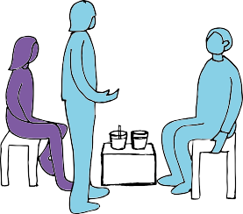

Children and young people may want to prepare something e.g. a PowerPoint, short film etc. to help to present their feelings and / or plans for the future and should be supported to do this. It is important to capture their views about their:

- Likes / dislikes
- Hopes, dreams and aspirations
- What support they need to stay healthy and safe

This will ensure that the child / young person can fully contribute – they may choose to express their views in a range of ways including drawings, pictures, symbols etc. Schools and parents / carers may already help children / young people to do this. Children / young people should also have, or be asked to prepare a ‘One Page Profile.’ (See example in Appendix D)

Equipment
- Plenty of flipchart paper
- Different colour marker pens
- Masking tape / blue tack

The specific headings should be written clearly onto the flipchart sheets prior to the annual review meeting. The use of flipchart paper should still be used even if the annual review meeting is being held virtually as the facilitator can write directly onto the sheets on behalf of the attendees.

It is extremely beneficial to spend time preparing for a person centred annual review meeting as this increases the chances of the meeting running smoothly and being both effective and productive.

The Facilitator



A person centred annual review meeting must have a facilitator – their role is to guide everyone through the different stages of the meeting, keeping things positive and possible and ensuring everyone is included in the discussions. 50% of the facilitation work involved in a person centred annual review meeting is graphic facilitation.

The facilitator must be identified in advance and their details shared with all invited parties prior to the Annual Review meeting. The facilitator is not the same as a chair person.

All person centred annual review meetings require flipchart paper (and marker pens), to place on the wall, to enable the facilitator to undertake their role effectively. It is important that the flipchart paper is at the required height for children / young people and / or their parents / carers.

Prior to the meeting the facilitator will record the child / young person’s existing outcomes and current provision (from Section E of the EHCP) onto flipchart paper and place them on the wall of the designated room.
The job of the facilitator is not to record every word said, but to record those contributions that are judged to be key. It is appropriate for the facilitator to check for clarity – not just to re-phrase or interpret what is being said. Graphics and symbols may be used when recording people’s contributions throughout the annual review meeting. Contributions should be as colourful and as visual as possible to keep everything person friendly and to ensure that it is clear for the child / young person.

The facilitator will ensure that all contributions are positive and possible and that everybody stays on track. It is also the facilitator’s job to ensure that everybody is included in the discussions.

It is usual for the facilitator to explain the steps to be taken at the start of the process and at the end of each step. The summaries need to be brief and aim to capture the highlights of the step that’s been completed. The facilitator will also check if anything has been missed or not adequately recorded.

The information captured on the flipchart sheets are vital to ensure everyone remains focused and bringing the A/R to life i.e. a picture of how the child / young person is presenting now and planning for their future.

Although much of the facilitator’s time is spent listening and recording what everyone is saying, this does not mean they are silent throughout the A/R meeting. From time to time the facilitator can use their own questions to help the group to move the meeting on. The facilitator will generally be responsible for timekeeping.


At the Annual Review Meeting

The agenda will need to be set in advance of the meeting and shared with the child / young person and all attendees. (See Appendix B for an Agenda Template)

The annual review meeting will still require someone to facilitate this new approach to the annual review process – this is not the role of the ‘facilitator’ referred to above.

The ‘process facilitator’ will work in tandem with the facilitator above. Their role will be to keep people on track, allowing only one person to speak at once and regularly repeating / reflecting what they have heard.

The facilitator will:
- Ask everyone to introduce themselves and briefly explain their relationship with the family and child / young person. This information will be recorded under the heading ‘Who is here?’ The facilitator records all the information on Flipchart sheet 1, which should be clearly visible to all in the room
- Establish the ‘Ground Rules’ (Flipchart sheet 2) for the meeting (e.g. mobile phones off, confidentiality, jargon free, spelling doesn’t matter etc. (See Appendix C) Once the facilitator has explained the ground rules there should be an opportunity offered to everybody to add to the ground rules. The ground rules can be adapted to the environment of the meeting and also to the needs and wishes of the family i.e. time allowed for interpretation, personal wishes if meeting is within someone’s home etc. There should always be a ‘five minute rule’ – if when issues are being discussed, they are not resolved within five minutes, they are then ‘parked’, referred to as ‘issues we are struggling with / questions to ask’ and added to the ‘Parking Board’ (Flipchart sheet 10) These are then added to the will be carried forward to the ‘Action Plan’ sheet to ensure they are discussed / resolved at a later date
- Ask everyone what they ‘Like and Admire’ about the child / young person and capture their answers (Flipchart sheet 3). This should include abilities, strengths, personal qualities, characteristics and all have a positive focus. The child / young person should also be invited to comment on what they like about themselves and what achievements they are most proud of

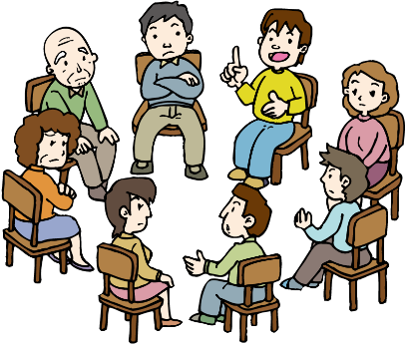

- Give all attendees a marker pen and invite everyone to write under each heading on each sheet of flipchart paper (approximately 15 minutes should be set aside for this activity). Some attendees may require some assistance with wording or offering to scribe on their behalf. In some cases, enabling attendees to write their thoughts onto ‘post-its’ that can be attached to the flipchart sheets can be less challenging.
The flipchart headings include:
  - What’s working? (Flipchart Sheet 4) The facilitator will record all issues, comments and suggestions. Remember the option at any time to relay issues that may be discussed longer than five minutes can be recorded on the ‘Parking Board’. This will gain an insight and understanding of how things are from all perspectives and support the next step
  - What’s not working? (Flipchart Sheet 5)
  - My Outcomes - Section E of the EHCP (Flipchart Sheet 6)
  - Important to and for (now)? (Flipchart Sheet 7) This should reflect what is important to and for the child / young person in their education, socially and regarding any health needs. This should be asked of all the people attending the meeting including the child / young person
  - Important to and for (future)? (Flipchart Sheet 8) This should reflect what is important to and for the child / young person in their education, socially and regarding any health needs. This should be asked of all the people attending the meeting including the child / young person
  - Action Plan (Flipchart Sheet 9)


Who is here?
Ground rules
Like and Admire

What’s working / what’s not working?

Outcomes

What’s important to & for (now and in the future)?

Action Plan

Parking board

The Action Plan

The Action Plan (Flipchart Sheet 9) should:
- Be developed together as a group – including input from the child / young person, whose input will make the action plan more effective
- Clearly outline who is going to do what and when
- Identify Actions, including targets / steps, that are SMART (Specific, Measurable, Achievable, Realistic and Time bound) – See Appendix G
- Concentrate on transition to the next phase of education
- Focus on Preparing for Adulthood:
  - Employment
  - Independent living
  - Community Inclusion
  - Health
- Include dates and timescales for all actions identified
- Identify priorities for discussion
- Support people to review, discuss and action from the information gathered under the headings
- Identify who will pursue the outcomes and check that the action plan is being followed

Closing the Meeting

The facilitator will finish by:

- Asking everybody what they appreciated about the meeting
- Offer people the chance to share their thoughts / feelings about the process and make suggestions for improvement. This information will inform the next annual review meeting
- Check who will be putting together the meeting notes and distributing them.

It is important that the school annotates the child / young person’s existing EHC Plan and return it to the SENAS Team with the completed annual review template (AR1), the minutes of the annual review and photographs / scanned copies of the flipchart sheets as a record that the annual review was completed using a person centred approach.

At the end of the meeting, the parents / carers and / or children / young people can take photographs of the flipchart sheets and have an immediate record of the annual review meeting.

They can use this to double check that nothing is overlooked, including:
- The annual report / minutes prepared by the educational setting (completed after the annual review meeting)
- Brent Council’s Annual Review Form completed by the educational setting (completed after the annual review meeting)
- The Action Plan drafted at the annual review meeting
- Any subsequent draft amended EHCP issued by Brent Special Educational Needs Assessment Service.

Section 4: Appendices

Flipchart Sheet Headings
Appendix A
Who is here? (Flipchart Sheet 1)

This will be your record of who attended the meeting

Ground Rules (Flipchart Sheet 2)

These will be established by the facilitator, agreed by everyone at the meeting and added to as required

Like and Admire (Flipchart Sheet 3)

This is a great way for evoking positivity for the children and young people and everybody involved in the annual review meeting.

How to Deliver?
Use as part of the welcoming process by asking people to write what they ‘like or
admire’ about the child / young person on flipchart sheet 2

You could also ask everybody in the room to write one thing they like or admire
about the child / young person on a sticky note and ask the child / young person to read out what everybody has written whilst attaching them to the flipchart sheet 2

What’s Working / What’s Not Working (Flipchart Sheets 4 & 5)

How to Deliver?
On a flipchart

Ask each attendee to write what they feel is working / not working for the child / young person at the moment

Working and not working from different perspectives contains two of the core principles of negotiation

When you get each person’s perspective on paper, they feel that they have been listened to and know they have contributed

This sheet can include information relating to the existing outcomes and how well they are being met

When you tease situations apart in enough detail, you can find areas of agreement. This enables you to start on common ground

Outcomes (Flipchart Sheet 6)

The EHCP outcomes will be added to this sheet prior to the review meeting

Important to & for (Now & Future) (Flipchart Sheets 7 & 8)

The aim is to develop two lists:
‘Important to’ means if it was taken away then the child / young person would greatly miss it. These are the things that are necessary for that child / young person to have a good quality of life, e.g. a mobile to text friends, DVD collection to relax or a teacher they can turn to

‘Important for’ is what is important for children / young people e.g. they are the things that help people become / stay healthy and safe, whether it is important to them or not, e.g. it is important that when people are asking me to do something that they use my communication dictionary to help me to understand what they are saying

Action Plan (Flipchart Sheet 9)

The facilitator will work with the group to develop the action plan

Parking Board (Flipchart Sheet 10)

The facilitator will add any issues to this sheet when discussions have exceeded 5 minutes and a resolution hasn’t been found

N.B. The flipchart sheet below is an example of Flipchart Sheet 3 and not created in an actual annual review

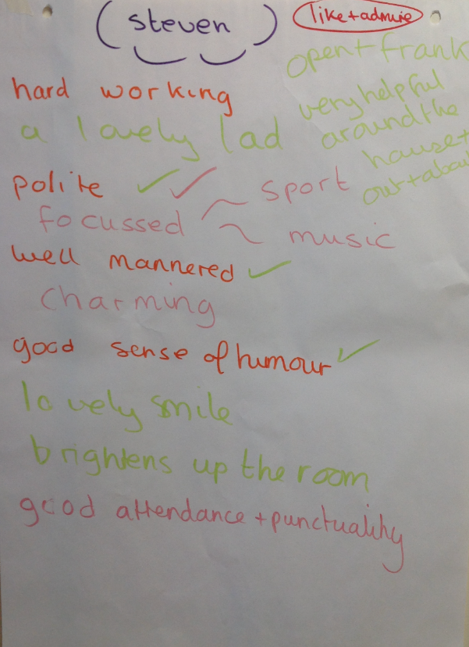

Annual Review Agenda Template
Appendix B

No. | Action | Comment / Explanation | Time
1 | Welcome / Introduction | The facilitator should welcome everyone, introduce him / herself & ask everyone to introduce themselves
2 | Ground Rules | The facilitator should explain how the review will be held and agree the ground rules
3 | Record who is at the meeting | Everyone should record their names on the ‘Who is here?’ sheet
4 | Like and Admire | Everyone should say what they like and admire about the child / young person. This includes strengths, personal qualities and characteristics
5 | What’s Working / What’s Not Working | The facilitator will summarise what is working & what is not working from the issues raised, for everyone to agree
6 | Outcomes
7 | What’s Important To and for the child / young person (now and in the future) | Everyone to say what they think is important to and for the child / young person both now and in the future
8 | Action Planning | This is the time to develop the actions that need to be taken and describe what the action is, who will take it and by when. It is important to date the actions giving an indication as to when the actions are to be reviewed regarding progress
9 | Closing the Meeting | The facilitator will finish by asking everyone what they appreciated about the meeting and will clarify who will be putting together the notes and distributing them

Ground Rules
Appendix C
There is no such thing as a silly question | ?
All contributions are valued | 
Listen without interruption | 
Use plain English – no jargon | 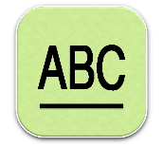
Spelling mistakes are OK | 
Confidentiality | 
The 5 minute rule | 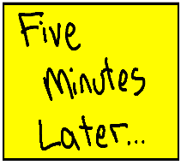
Turn mobiles off / silent | 

The Person Centred Planning Approach to Annual Review Meetings – Checklist

Appendix D

Action | Completed
Liaise with parents / carers & young people at the start of the academic year about possible dates for the A/R
Schedule the time and date of the Annual Review (A/R) and share date / time with the SENAS Team via SEN.reviews@brent.gov.uk
Schedule the PEP meeting at the same time as the A/R if the child / young person is a Looked After Child
SENAS Team to arrange the A/R if the child / young person is Electively Home Educated

Identify who will take on the role of both the facilitator and the process facilitator

Determine who needs to be invited to the A/R meting (Liaise with the family to ensure everyone they want to be there is invited)
Prepare and send A/R (the child / young person might like to complete (or be supported to complete) their own invitations
Offer to meet the parents / carers prior to the A/R to explain the process and enable them to ask any questions
Speak to the child / young person about the A/R meeting, explain what will happen and enable them to ask any questions
Speak to the child / young person to determine:
- Which room in the school they would like to have their A/R
- What language they would like spoken in the annual review and if they want an interpreter (If English is their second language)
- Do they want to bring an item that is meaningful to them to the annual review meeting
- What refreshments would they like to have available on the day (e.g. to drink, biscuits etc.)
- What (if any) music would they like played when people are arriving to / leaving the meeting
- What are their favourite colours – to try to get marker pens in the colour they like
- What chair (if appropriate) would they like to sit on – so they are able to feel as comfortable as possible when they are in attendance
Support the child / young person with:
- Presenting their views about their feelings and plans for the future (e.g. a short film, PowerPoint etc.)
- Completing their ‘One Page Profile’
Prepare and collate all of the paperwork / reports prior to the A/R meeting

Circulate all paperwork / reports to all attendees well in advance of the meeting

Source flipchart sheets and marker pens (in the child / young person’s favourite colours if required) to use in the A/R
Write the child / young person’s existing outcomes (as per Section E of their Education Health and Care Plan) on one of the sheets of flipchart paper
Ensure that:
- The room that the child / young person asked for is ready
- The temperature of the room is suitable for everyone
- Refreshments (that the child / young person asked for) are readily available
- Music (that the child / young person requested) is ready to play whilst people are arriving & leaving
- There are enough chairs for everyone attending, including a chair that the child / young person said they would like to sit on (if appropriate)
- The flipchart sheets are stuck on the walls at an appropriate height for everyone to access. The sheets should have the relevant headings on them (see page 10 to 11), including the Current Outcomes as referred to above
The Facilitator welcomes everyone to the A/R and ensures that they sign in on the ‘Who is here’ sheet
The facilitator will set out the ground rules of the meeting, including keeping to time
Proceed with the A/R meeting as described
The facilitator brings the A/R to a close and thanks everyone for their input and attending the meeting
Complete the A/R report / meeting minutes after the A/R meeting has finished
Complete Brent’s A/R template (AR1) after the meeting has finished
Clearly annotate the existing EHCP with any amendments / additions / deletions
Send all of the following to Brent’s Special Educational Needs Assessment Service via SEN.reviews@brent.gov.uk and to parents / carers:
- The annual report / minutes
- Brent Council’s Annual Review Form template (AR1)
- Scanned copies / photographs of all of the flipchart sheets used in the annual review
- The annotated EHCP clearly showing amendments / additions / deletions

One Page Profile
Appendix E
Here is an example of a One Page Profile template with explanatory notes of a young person who can share his or her views (within the context of a supportive conversation with family, friends, school staff etc. as appropriate). If the One Page Profile is being developed for someone who can’t express their views and you are sharing other peoples’ views regarding this person please use their name.

Photo of child / Young Person | What people like and admire about me...  Ask people who know me, including friends and family, what they like and admire about me - this should be a list (short phrases) about me rather than a list of things I have done.  Include strong, positive  statements avoiding words like 'usually' or 'sometimes'
What is important to me...  A list of what really matters to me that quickly shows people, who may not already know me, what is important and matters to me.  This should be detailed and specific to me & my life & should help people to understand who I am.  This section should include what is most important to me rather than just being a list of my likes and dislikes.  This section could include:  - Who is important to me in my life & when and how I spend my time with them  - Things that interest me  - Anything I have that is important to me  - Information about how I live my life. This could also include what I do every day in my life | How best to support me...  Information about how best to support me will help to create the best situation and outcomes for you.  This section includes information that people need to either get to know me better or what they need to know in order to heighten the chance of having a positive time together.  It is best to be very specific so that if I need support quickly it is likely to be the correct type and level of support.  This section can include some pointers as to what is helpful for me and what is not

Examples of Person Centred Planning Annual Review Invitations
Appendix F
Example 1
To those invited to the annual review
Dear [name],
Please come to my review meeting on [date] at [time]
People at the meeting will include my family, my teacher and other adults who know me.
At the meeting we will write about and talk about:
- What you like and admire about me
- What is important for me and my future
- What is working and not working now
- My support - what’s in place and what needs to be put in place for me
We will also talk about my progress in school and my Education, Health and Care Plan.
Then we will make an Action Plan for my future.

Please let me know if you can come.
Yours sincerely,
[Invitee’s name]
Child / young person

Example 2
To the friend of the child / young person:

Dear [name],
[Invitee’s name] is invited to attend a meeting on [date] at [time] to help his / her friend [name] to think about his / her future.

The meeting is called an annual review. This is a positive, respectful, friendly approach to planning in a person-centred way.

We are inviting people who love [name], care deeply about her / him, are friends with or are key stakeholders in her / his future.

At the meeting we will listen to [name’s] dreams and share our own dreams for her / him. We will also plan with [name] some achievable goals for the next year as part of an action plan.

I hope you are in agreement with [child’s name] attending.
Many thanks

SMART targets
Appendix G

When a child / young person needs something additional to or different from the majority of children / young people it is important to have documentation in the form of a personalised individual plan to ensure that a person-centred approach is adopted. This should form part of the graduated approach to improve outcomes and attainment for children with a special education need or disability (SEND), measure interventions and support parental engagement.
SMART targets are targets that are Specific, Measurable, Achievable, Realistic and Time bound whilst also being personal to the child / young person. They should be set as small steps towards the child / young person meeting their long term outcomes. In addition, they should form part of a graduated approach to supporting children / young people in consultation with parents / carers.
It is important to ensure that targets are used when planning for children / young people and not aims. An aim is a long term goal whereas a target is a statement of what the child / young person can achieve within a given time. For example if the aim for Clive is to know the names of colours. The target might be for ‘Clive to point to a red wooden block when asked by his keyworker, when presented with 2 red wooden bricks and a yellow wooden brick (3/5 tries)’.

Paragraph 9.66 of the SEND Code of Practice (DfE, 2015) states that:
An outcome can be defined as the benefit or difference made to an individual as a result of an intervention. It should be personal and not expressed from a service perspective; it should be something that those involved have control and influence over, and while it does not always have to be formal or accredited, it should be specific, measurable, achievable, realistic and time bound (SMART). When an outcome is focused on education or training, it will describe what the expected benefit will be to the individual as a result of the educational or training intervention provided. Outcomes are not a description of the service being provided – for example the provision of three hours of speech and language therapy is not an outcome. In this case, the outcome is what it is intended that the speech and language therapy will help the individual to do that they cannot do now and by when this will be achieved.

Specific
This part of the planning process is about making sure that targets or outcomes are very specific. Working out small ‘next steps’ for individual children is a skilful process and takes a great deal of practice. Targets must be expressed using clear language describing exactly what a child / young person will be able to do or say to be successful.

For example:

Words that are unclear | Detailed replacements
Know (numbers to 10) | - Say the numbers to 20  - Or point to the numeral when named
Listen | - Answer questions afterwards  - Re-tell part of the story
Identify | - Point to  - Name
Understand | - Give the amount requested  - Count the number of items

Measurable
As outlined in the Code of Practice it is a requirement that practitioners show that children / young people are making progress and that identified targets have been achieved. The degree of success is often stated as the number of times a child / young person responds successfully out of the total number of times practiced. This may also include a time or frequency factor to decide whether a child / young person has been successful. For example, being able to feed yourself would not be a particularly useful skill if it takes 3 hours.

Achievable
Targets must be realistic and within the child / young person’s ability as identified in ongoing assessments. For example it may be unrealistic for a child / young person with a communication difficulty to be expected to verbally express when they need to use the toilet. It might be more realistic for them to point to a picture or use a Makaton sign.

Relevant
Targets must be tailored to the child / young person’s individual needs. The targets should be linked to the child’s desired outcomes.

Time-bound
SMART targets or outcomes must always have a specified date by which it is hoped the child / young person will have successfully achieved them and at this point the targets should be reviewed to assess progress.

Examples of SMART targets:
- Joseph will lace his shoes, when given verbal instructions, 4/5 tries
- Ihram will name red, when given the initial sound prompt ‘It’s’ r, r, 3/6 tries
- Sarah will walk forward 6 steps, when the adult holds both her hands and she is wearing her gaiters, 6/8 tries
- Lucy will put the third brick on top of the tower of two bricks, when the adult holds two bricks to steady them, 4/6 tries
- Tia will vocalise her choice of snack when given two options four days out of five
- Sam will put a six piece puzzle together, without any adult help, 2/3 tries
- Charlotte will select 3 objects when asked by an adult 4/5 times
- Bobby will catch a large ball, when it is rolled towards him along the floor, 7/10 tries
- Frankie will retell part of a story that a practitioner has read to him 4/5 times
- Tez will be able to answer a question an adult asks him about himself 3/5 times
- Laurie will name 6 farm animals, when an adult points to them in a book, 5/6 tries
- Max will join in with the last few words of a familiar rhyme or song, as part of a small group 60% of the time by the end of the half term.
- Ella will hold an ordinary cup and drink from it at snack and lunch times without prompting 4/5 times
- Ahmed will use phrases (more than two words) when talking to an adult about something he has done or something he’s brought from home twice a day
- Charlie will point to his preferred choice of snack when given a choice of two 3/5 times
- Archie will recognise the numbers 1-5 when asked by an adult 80% of the time
- Harrison will count from 10-20 when instructed by his key person 4/5 times

