Meanwhile Use

Feasibility Study Template

<PROJECT_NAME>



Contents

1 Introduction 3
Meanwhile Use in Brent Council 3-4
Policy Context 4
Meanwhile Leases 4
Successful Examples 5

2 Council Recommendations & Requirements 6
Use Recommendations 6
Meanwhile Requirements 7
Process 8
Commuted Sum Calculation 8
Model of Operation: Option A & Option B 9

3 Meanwhile Use Feasibility Form 10
Site Analysis 11-12
Costs 13
Programme 14
Initial Proposal 15
Summary and Conclusions 16

Appendix 1: Section 106 Clauses 18-20
Appendix 2: Planning Condition 21-22
Appendix 3: Heads of Terms 23-24

Introduction
Meanwhile use describes the activation of vacant or underused spaces, buildings and development sites with temporary uses which have an agreed end point, but that can sometimes be extended into the longer-term regeneration of an area.
This temporary activation has many advantages, and is in the interest of local stakeholders:
- placemaking;
- increasing social and economic value in an area;
- supporting local organisations, creatives, microbusinesses and SMEs;
- strengthening safety and the community;
- making better use of scarce land and property resources;
- and strengthening safety and the community
There are also many benefits for owners/developers such as:
- reducing owners property holding costs and business rates liabilities;
- increasing security and reducing risk of crime and antisocial behaviour on site;
- testing viability of future uses at the site;
- and building relationships with the local community and businesses
There are many types of meanwhile use, responding to demands of the local community, from open green spaces through to community hubs and/or pop-ups. These all have the power to vitalise areas and create places that people want to be in.
Phased development provides opportunities for meanwhile uses. Brent Council requires owners/developers to assess the feasibility for meanwhile uses on all phased major developments within Growth Areas and Town Centres. A feasibility study should assess the social and economic viability of the planned meanwhile use in a specific locale.

Meanwhile Use in Brent Council
Brent Council supports meanwhile uses across the borough, and in 2021, the Brent Meanwhile Use Strategy and Action Plan (MUS) was adopted. This includes a detailed action plan to encourage developers, land owners, landlords, businesses and communities to get involved in meanwhile opportunities.
Brent Council is working on delivering meanwhile use in the borough, following the adoption of its MUS. This strategy aims to facilitate a consistent and joined up approach to the planning and delivery of meanwhile use projects between the Council and its partners, to increase their scope and reach, and maximise their social and economic benefits for Brent businesses and residents.
Brent’s adopted Local Plan supports the use of vacant and under-utilised sites or buildings for occupation by temporary uses that will benefit a Town Centre or Growth Area’s viability and vitality and requires that all phased major developments within Town Centres or Growth Areas to submit a Meanwhile Feasibility Study and if deemed feasible, develop an appropriate Meanwhile Proposal/Strategy.
Land awaiting development can be put to temporary use directly by the landowner/ developer or by appointing the services of a Meanwhile Provider, an organisation with experience delivering meanwhile use projects. Brent offers an up-to-date list of approved Meanwhile Providers that must fulfil a set of minimum standards defined by the council to efficiently develop and operate projects with added value and qualify for the approved list.

Planning Policy Context
Brent Council’s meanwhile use policy responds to the vision and objectives outlined in the London Plan 2020, in promoting efficient land use and securing social value through temporary uses. The following London Plan policies encourage meanwhile use:
- H3: Meanwhile use as housing
- SD7 (C7): Town Centres: development principles and Development Plan Documents
- D8 (M): Public realm
- HC5 (C4): Supporting London’s culture and creative industries
- G8 (A1): Food growing
These are reflected at a local level in the adopted Brent Local Plan 2022, including Policy BE4:
“All phased major developments within Town Centres or Growth Areas will be required to submit an appropriate Meanwhile Feasibility Study and if feasible, an appropriate Meanwhile Strategy/Proposal. Proposals for workspace, new markets, including farmers’ markets and street-food markets, will be encouraged as well as other seasonal/ temporary uses. Temporary entertainment and leisure uses will be supported, particularly those which enhance and promote Brent’s heritage and culture.”
- BE4: Supporting Strong Centres – Meanwhile Uses (SD7)
- BE6: Neighbourhood Parades and Isolated Shop Units (D8, HC5)
- BHC4 Brent’s Night Time Economy (SD7)
- BGI1 Green and Blue Infrastructure in Brent (G8)
Local Plan site allocations recognise and encourage meanwhile uses within the Wembley Park Growth Area. In addition, Brent’s Affordable Workspace Supplementary Planning Document (SPD) strongly correlates with meanwhile use workspaces. It highlights affordable workspace (such as artist studios, enterprise and incubators space) has potential to reinvigorate and diversify Town Centres and high streets.

Meanwhile Leases
The Ministry of Housing, Communities & Local Government (MHCLG) drafted a template to provide industry standard meanwhile leases to minimise administrative and legal costs for both landlords and tenants and to allow temporary occupation of empty Town Centre retail premises: https://www.gov.uk/government/collections/meanwhile-use-leases-and-guidance-for-landlords Meanwhile leases can be developed in partnership with Meanwhile Providers and allow for much shorter term lease and occupation of vacant premises.

Successful Examples of Meanwhile Use in Brent
Successful meanwhile use projects in Brent include examples from a spectrum of models.
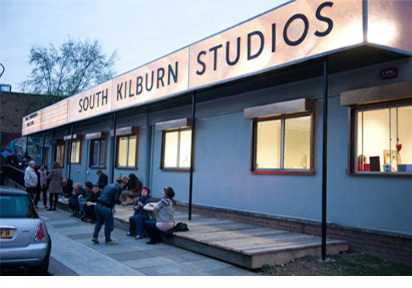  South Kilburn Studios (2011-2013) was a disused portacabin on local authority land zoned for estate regeneration and converted into creative studio spaces that trained local youth in exchange for rent free occupation. The initially six-month project was extended to two years demonstrating its success. The project was a partnership between the public, private and third sector: Council, South Kilburn Neighbourhood Trust, The Architecture Foundation and Practice Architecture. | 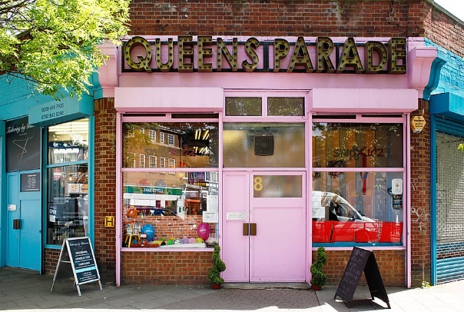  Queens Parade, Willesden Green (2012 – Present) is a Local Plan site allocation for redevelopment. Meanwhile Space, supported by the Council and the GLA Outer London Fund, transformed the eight vacant units into one of London’s top shopping locations through its innovative approach with shops offering retail and community workshops and skill exchanges planned with public participation.
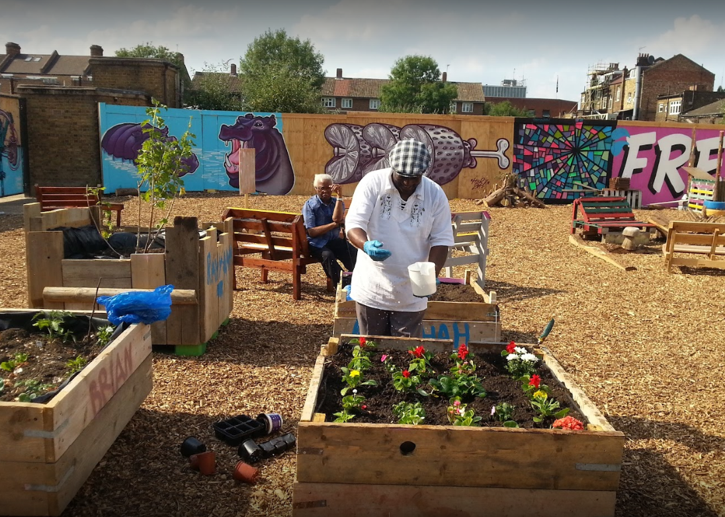  Nomadic Community Garden, Queens Park (2017), following success in Brick Lane, London newcastle collaborated with Brent Council to bring a Nomadic Community Garden to a vacant site in Queen’s Park in 2017. The not-for-profit social enterprise temporarily transforms empty spaces into community spaces where people can grow food, create art and share skills. Activities include mosaic workshops using recycled objects, smoothie making, beekeeping, fruit harvesting and DIY workshops. | 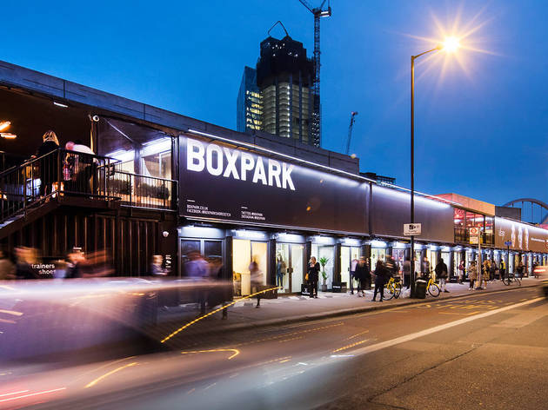  BOXPARK Wembley (2018), a 10 year joint venture to accelerate regeneration on Quintain’s Wembley Park site and accommodates up to 30 independent food and beverage operators offering drinks, eating and events spaces.  The first BOXPARK in Bishopsgate Goods Yard, Shoreditch opened in 2011, and another site in Croydon opened in 2016. BOXPARK was conceived as a way of delivering meanwhile uses on brownfield or under-utilised sites pending permanent redevelopment.
For more examples, see: https://www.brent.gov.uk/business/regeneration/meanwhile-uses/projects-in-brent/successful-projects

Council Recommendations & Requirements

Use Recommendations
There are many types of meanwhile use opportunities at different sites, some of which have been illustrated in the diagram below. The type of use that best suits a site will depend on the nature of the site, location, and surrounding uses and infrastructure.
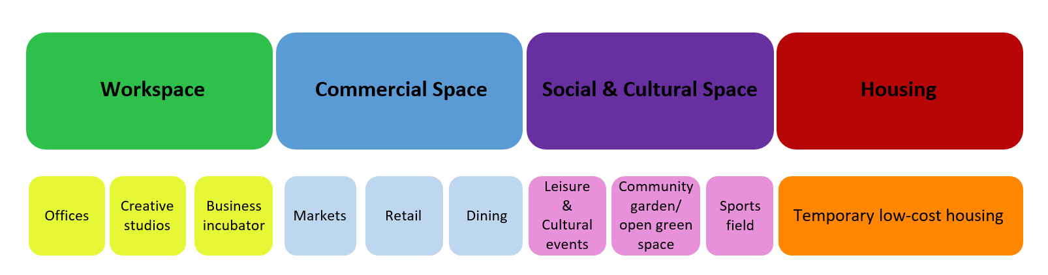
- Examples of meanwhile use areas of demand
Recommendations for designated Growth Areas and Town Centres are also defined by the council in its adopted Meanwhile Use Strategy (see p.31-50), these must be considered when developing the meanwhile use proposal. The Council offers a variety of recommended uses depending on the type of space (see Table below).
Type of Space | Recommended Uses
Open space or vacant lot | Community garden, food growing, meanwhile gardens, pop-up market, events (eg: festival), sports ground, use of portacabins, temporary housing solutions, temporary public space interventions
Unoccupied ground floor of residential blocks | Creative hub, community spaces, affordable workspaces
Building intended for demolition/ refurbishment | Youth centre, community kitchen, shops, pop-up retail, cultural centre, artist studios
Vacant residential units | Temporary housing
Larger high street units | Cultural spaces, community kitchen, affordable workspace, community space
Smaller high street units | Neighbourhood cafe, smaller social business, affordable studios
Industrial property | Creative hubs, event spaces, temporary cultural spaces (cinema, theatre, gallery), mixed-use social and makerspace
Empty office block or floors in block | Affordable workspaces, temporary accommodation, community spaces
Table 1 Recommended Meanwhile Uses

Meanwhile Requirements
Evictions
Existing tenants must not be evicted for meanwhile uses.
Process
In this context, major phased developments refers to all phased mixed use developments and any phased residential scheme with over 40 units.
Meanwhile projects as part of phased developments are to be provided on a peppercorn rent to Meanwhile Providers or Charities/CICs/CIOs.
Developers must submit a Meanwhile Feasibility Study at pre-planning application stage using the Council’s template.
Developers must submit a Meanwhile Use Proposal/Strategy with planning application using the Council’s template.
Developers must submit signed Meanwhile Use Heads of Terms with planning application (see what are the minimum terms to include in a Meanwhile Use Heads of Terms in Appendix 3).
Meanwhile terms would usually be secured in a section 106 (see s106 template in Appendix 1), and when this is not feasible (for example on a Council scheme), we would secure meanwhile terms in a planning condition (see planning condition wording in Appendix 2).
Specification Requirements
SITES/PROPERTIES VACANT FOR LESS THAN 12 MONTHS:
Ahead of meanwhile uses, Owners/Developers must (unless otherwise agreed in writing with the Council):
-Confirm compliance with all relevant health and safety, fire and building regulations
-Units in new developments must be delivered with fenestration
SITES/PROPERTIES VACANT FOR OVER 12 MONTHS:
Ahead of meanwhile uses, Owners/Developers must (unless otherwise agreed in writing with the Council):
-Confirm compliance with all relevant health and safety, fire and building regulations
-Ensure all statutory services (water, electricity, gas) are supplied, capped, tested and separately metered, and all drainage to be installed and connected where relevant
-Units in new developments must be delivered with fenestration

Regulatory Process
Sign Off Process Diagram:
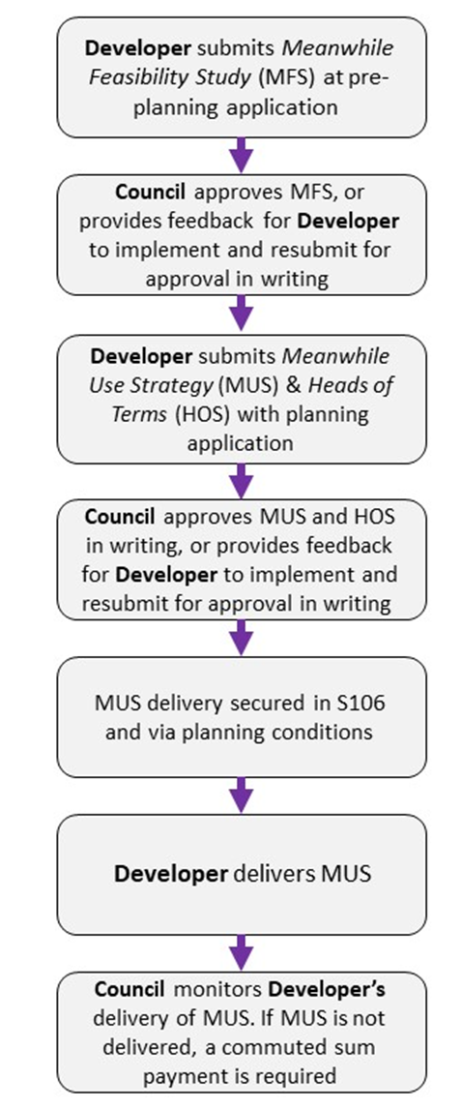
- Sign Off Process

Commuted Sum Calculation:
Step 1 – Floor area (sq ft) (NIA) x £11.61 per sq ft = rent per annum
Step 2 – Rent per annum capitalised at the yield for 12 months = capital value of the meanwhile space. The capital value would be the commuted sum.

Meanwhile Project Model of Operation
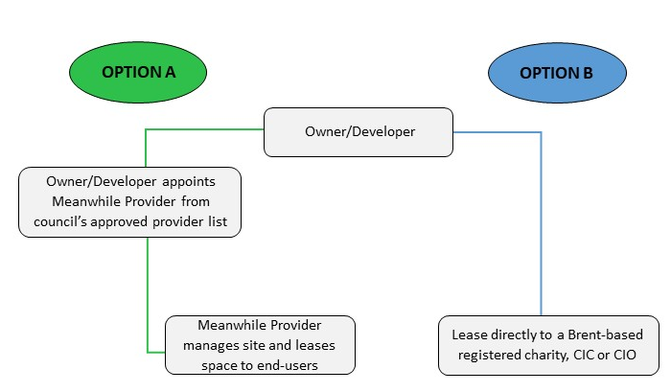
Figure 3 Options of Model of Operation

OPTION A: Development by Appointed Meanwhile Provider
The council publishes a list of Meanwhile Providers with proven experience in creating places for temporary use with added social value on its website. Unlisted providers are encouraged to join the Council’s Meanwhile Provider List.
The Owner/Developer signs a lease with a Meanwhile Provider on a peppercorn rent (unless otherwise agreed in writing with the council) for the agreed minimum duration of the meanwhile use and the Meanwhile Provider occupies and manages the site.
The Owner/Developer must get Heads of Terms approved by the council in writing (see Appendix 3). The lease between the Owner/Developer and Meanwhile Provider would then be based on the approved Heads of Terms (unless otherwise agreed in writing by the council).

OPTION B: Owner/Developer Leases Site to Charity based in the Borough
The Owner/Developer signs a lease for a charitable, not for profit, CIC or CIO end user that is registered and based in the Borough to use the space on a peppercorn rent (unless otherwise agreed in writing by the council).
The Owner/Developer must get Heads of Terms approved by council in writing (see Appendix 3). The lease between the Owner/Developer and charity/CIC/CIO would then be based on the approved Heads of Terms (unless otherwise agreed in writing by the council).
The Council will consider credible Developer/Owner direct delivery of meanwhile uses in exceptional circumstances, such as if a developer has a track record delivering successful meanwhile uses. For example, developer Quintain Ltd delivered meanwhile use at their sites in Wembley Park, signing leases with Boxpark and the Troubadour Theatre (see more details on p. 5).

MEANWHILE USE FEASIBILITY STUDY FORM

Sections A to D below set out the meanwhile feasibility details that are to be completed for the site or property.
Once finalised, the Meanwhile Feasibility Study Form is to be submitted to the council with planning pre-application for review.

A. Site Analysis:
ITEM | RESPONSE
Location

1. Outline the location and boundaries of the site intended for a meanwhile use with aerial plan and photos, and describe the neighbourhood and wider area.
Size

2. Demonstrate size of site and different properties involved (NIA/GIA/GEA), with floorplans or drawings if available.

Condition

3. Outline condition of site and/or properties concerned, including photos of the site and/or building.

Specification
4. Provide information on specification of site/property (including what services are available and ready to use, or are accessible; any land contamination/site hazards; asbestos register; health and safety file; current fire plan; and confirmation of building control compliance).

If available and applicable provide Fire Safety Certificate, Energy Performance Certificate (EPC), NICEIC Electrical Safety Certificate, Gas Safety Certificates, Legionella Certificate, Asbestos Register.

See minimum requirements on page 7.

Use Class

5. Outline the site’s planning use class and any planning restraints or conditions on the site, and details of when and for what the site was last used if applicable.

B. Costs:
ITEM | RESPONSE

Rent

6. Site or property to be provided to Meanwhile Providers or charities on peppercorn rent for the duration of the project (unless otherwise agreed in writing with the council).

Running Costs

7. Outline known running costs and business rates at the site.

8. Running costs on the property and business rates are to be covered by the Meanwhile Provider or end user using the site.

C. Programme:
ITEM | RESPONSE

Project Programme

9. Provide high level programme of the major development project being proposed, setting out duration of project as well as the location of the different phases if available.

Length of Tenure

10. Demonstrate how long site will be vacant for and minimum length of tenure for meanwhile use(s) at the site.

D. Initial Proposal:
ITEM | RESPONSE

Tenant Engagement

11. Demonstrate proof of engagement with Meanwhile Providers and/or Brent-based charity/CIC/CIO and include whether they are interested in occupying the site.
Set out initial proposal to use the site based on site analysis and engagement with Meanwhile Providers and/or charities.

SWOT Analysis

12. Provide analysis on the strengths, weaknesses, opportunities and threats of the initial meanwhile proposal.

Council Corporate Strategies

13. Highlight how the initial proposal aligns with any Brent Council adopted corporate strategies e.g. the Borough Plan, Local Plan, Inclusive Growth Strategy, Meanwhile Use Strategy, Affordable Workspace Strategy, Black Community Action Plan, Climate Emergency Strategy.

E. Summary and Conclusions:
ITEM | RESPONSE
14. Analyse the findings of the feasibility study weighing the financial, physical and logistic viability against the social impact on the community and draw conclusions with regard to the potential of the proposal.

The Meanwhile Feasibility Study must be sent to the Council for approval alongside the developer’s pre-planning application.
The council may seek clarification or request further information from the Owner/Developer as part of its assessment of the application.

Meanwhile Use Strategy/Proposal
In the case that meanwhile use is deemed feasible at the site and/or property, a Meanwhile Strategy/Proposal should be developed as soon as practical.
The appropriate model of operation should be chosen (Option A or Option B, see p.9).
The Meanwhile Feasibility Study should be distributed with Meanwhile Providers or charity occupiers to invite their proposals, depending on which model of operation is chosen.
The Meanwhile Use Strategy should be developed in a separate document by the selected Meanwhile Provider or charity and approved by the Developer/Owner.
The Meanwhile Strategy should include:
- Proposal for the site;
- Site analysis (location, social context, local economy and community needs);
- Social value projections;
- Relevant case studies;
- Move-on strategies and phasing plan
Further details and templates for both Meanwhile Use Strategy options can be found on the Council’s website.
Appendix 1: Meanwhile Use Clauses to be used in Section 106 Agreement
MEANWHILE USE TO BE USED IN S106 AGREEMENTS
DEFINITIONS AND INTERPRETATIONS

Meanwhile Use | temporary use of the site ahead of commencement of works or during phased developments
Meanwhile Use Occupier | means any resident, business, organisation or group that is eligible to occupy the Meanwhile Use site
Meanwhile Use Strategy | is the Strategy relating to the use and occupation of the Meanwhile Use and which is to include the following (although not an exhaustive list):  (a) Location  (b) Stakeholder mapping  (c) Public engagement  (d) Proposal  (e) Social value projections  (f) Environmental impact  (g) Move-on strategy
Approved Meanwhile Operator | means:  (a) the Council; or  (b) any organisation incorporated for the provision of meanwhile use (as approved by the Council on its website)
Brent’s Approved Meanwhile Operator List | Meanwhile Operators that have been approved on Brent’s website
Lease Agreement | Means a binding legal agreement for the disposal of the Meanwhile Use site to a Meanwhile Operator or Brent-based Charity, Community Interest Company (CIC) or Charitable Incorporated Organisation (CIO)
Meanwhile Use Contribution | means a financial contribution in the sum of [ ] pounds (£[ ]) which payable to the Council by the Owner
Meanwhile Heads of Terms | means a document setting out the terms of the commercial lease (which is to be entered into by the Owner and the Meanwhile Operator or Brent-based charity, CIC or CIO) for the Meanwhile Use space and which are to include:  (a) the tenancy term period  (b) peppercorn rent  (c) service charges  (d) the extent of the demised area
Schedule [ ]

1. The Owner covenants:

a) that the Meanwhile Use is made available for use and is operated in accordance with the approved Meanwhile Use Strategy, as approved by the Council in writing (as amended from time to time and agreed by the Council in writing);
b) to submit a report to the Council summarising the actions taken to implement the approved Meanwhile Use Strategy and future actions associated with the implementation of the Meanwhile Use Strategy, at 6 monthly intervals following Commencement of the Development
c) to use all reasonable endeavours to enter into and complete the Lease Agreement with the selected Meanwhile Operator (from Brent’s Approved Meanwhile Operator List) or a Brent-based charity, CIC or CIO on a peppercorn rent, in accordance with the approved Meanwhile Heads of Terms, unless otherwise agreed in writing with the Council

2. The Owner shall pay to the Council the Meanwhile Use Contribution (within 20 Working Days) in the event that:
a) the Meanwhile Use Strategy has not been submitted by the Owner
b) the Owner has not provided the reports required through Part 1.b. at 6 monthly intervals following submission of the planning application
c) the Meanwhile Use Strategy has not been implemented in full by the Owner after 12 months of being approved

3. The Owner covenants [for sites that are vacant for more than 12 months]:
a) that all fenestration is to be installed for the Meanwhile Use;
b) that all relevant health and safety, building and fire regulations and requirements are met for the Meanwhile Use;
c) and that all statutory services including electricity are to be supplied, capped, tested and separately metered and drainage to be installed and connected for the Meanwhile Use

The Owner covenants [for sites that are vacant for less than 12 months]:

a) that all fenestration is to be installed for the Meanwhile Use;
b) and that all relevant health and safety, building and fire regulations and requirements are met for the Meanwhile Use

4. The Owner shall procure that the Meanwhile Operator or Brent-based charity, CIC or CIO submits a report to the Council annually setting out details of all Meanwhile Space users, rent charged to each Meanwhile Occupier and provide copies or procure that the Meanwhile Operator provides copies of all occupational leases/licences granted to Meanwhile Occupiers and any other information or data required by the Council.

Appendix 2: Meanwhile Use Planning Condition

Example of a Meanwhile Planning Condition:

“Prior to commencement of works (excluding demolition, site clearance, services and below ground works), a Meanwhile Use Strategy, in line with the Council’s adopted template, shall be submitted to and approved in writing by the Local Planning Authority, and implemented in full thereafter until the relevant unit(s) and/or space(s) are permanently occupied, unless a revised Meanwhile Use Strategy is subsequently submitted to and approved in writing and thereafter implemented in full until permanent occupation.
Reason: to ensure that the development makes an appropriate contribution to the vitality and viability of the [town centre / growth area] in accordance with Local Plan Policy BE4.”

Appendix 3: Heads of Terms

Meanwhile Use Heads of Terms
Meanwhile Use Heads of Terms means a document setting out the terms of the commercial lease (which is to be entered into by the Owner and the Meanwhile Provider or Brent-based charity, CIC or CIO) for the meanwhile space.

Items to include (at a minimum):
-That it is a peppercorn rent
-Type of lease (for example: a Meanwhile Lease)
-Extent of the demised area
-Schedule of landlord’s works to be carried out prior to the occupation of the unit (if applicable)
-List of tenant works (if applicable)
-Deposit (if applicable)
-Tenancy term period (and any break clauses)
-Anticipated date of occupation
-Assignment and subletting
-Services and service charge (if applicable)
-Rates
-Repairing obligations
-Alterations (if applicable)
-Permitted use
-Insurance
-Legal costs
-Conditions
-Note stating that Heads of Terms is contingent on the planning application being approved and project going ahead

*F1/F2 (Previously D1/D2) average rental value, source: London Borough of Brent: Financial contributions tariff on smaller developments

